**Merge Sort**

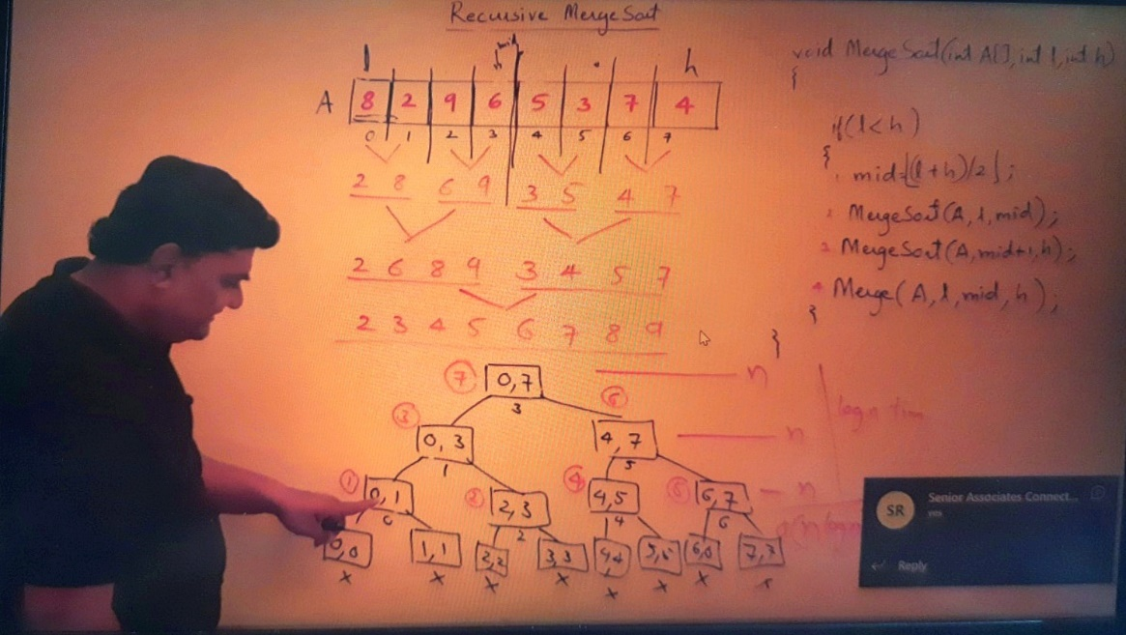

Merge sort is defined as a sorting algorithm that works by dividing an array into smaller subarrays, sorting each subarray, and then merging the sorted subarrays back together to form the final sorted array.

In simple terms, we can say that the process of merge sort is to divide the array into two halves, sort each half, and then merge the sorted halves back together. This process is repeated until the entire array is sorted.

### Need for Merge Sort

One thing that you might wonder is what is the specialty of this algorithm. We already have a number of sorting algorithms then why do we need this algorithm? One of the main advantages of merge sort is that it has a time complexity of O(n log n), which means it can sort large arrays relatively quickly. It is also a stable sort, which means that the order of elements with equal values is preserved during the sort.

Merge sort is a popular choice for sorting large datasets because it is relatively efficient and easy to implement. It is often used in conjunction with other algorithms, such as quicksort, to improve the overall performance of a sorting routine.

## Merge Sort Working Process:

Think of it as a recursive algorithm continuously splits the array in half until it cannot be further divided. This means that if the array becomes empty or has only one element left, the dividing will stop, i.e. it is the base case to stop the recursion. If the array has multiple elements, split the array into halves and recursively invoke the merge sort on each of the halves. Finally, when both halves are sorted, the merge operation is applied. Merge operation is the process of taking two smaller sorted arrays and combining them to eventually make a larger one.

### Illustration:

To know the functioning of merge sort let’s consider an array arr[] = {38, 27, 43, 3, 9, 82, 10}

* At first, check if the left index of array is less than the right index, if yes then calculate its mid-point

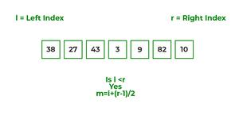

* Now, as we already know that merge sort first divides the whole array iteratively into equal halves, unless the atomic values are achieved.
* Here, we see that an array of 7 items is divided into two arrays of size 4 and 3 respectively.

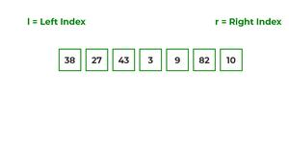

* Now, again find that is left index is less than the right index for both arrays, if found yes, then again calculate mid points for both the arrays.

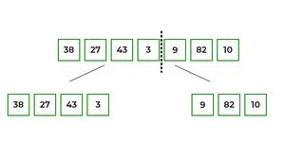

* Now, further divide these two arrays into further halves, until the atomic units of the array is reached and further division is not possible.

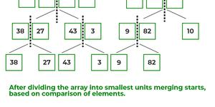

* After dividing the array into smallest units, start merging the elements again based on comparison of size of elements
* Firstly, compare the element for each list and then combine them into another list in a sorted manner.

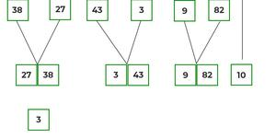

* After the final merging, the list looks like this:

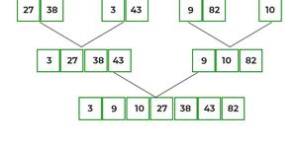

The following diagram shows the complete merge sort process for an example array {38, 27, 43, 3, 9, 82, 10}.

If we take a closer look at the diagram, we can see that the array is recursively divided into two halves till the size becomes 1. Once the size becomes 1, the merge processes come into action and start merging arrays back till the complete array is merged.

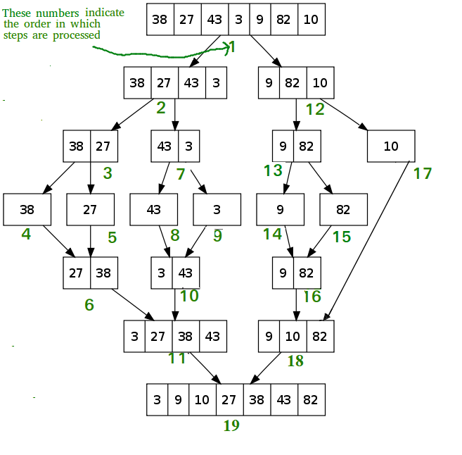

*Recursive steps of merge sort*

**Algorithm:**

**step 1: start**

**step 2: declare array and left, right, mid variable**

**step 3: perform merge function.  
    if left > right  
        return  
    mid= (left+right)/2  
    mergesort(array, left, mid)  
    mergesort(array, mid+1, right)  
    merge(array, left, mid, right)**

**step 4: Stop**

Follow the steps below to solve the problem:

**MergeSort(arr[], l,  r)  
If r > l**

**Find the middle point to divide the array into two halves:**

**middle m = l + (r – l)/2**

**Call mergeSort for first half:**

**Call mergeSort(arr, l, m)**

**Call mergeSort for second half:**

**Call mergeSort(arr, m + 1, r)**

**Merge the two halves sorted in steps 2 and 3:**

**Call merge(arr, l, m, r)**

|  |
| --- |
| /* Java program for Merge Sort */  **class** MergeSort {      // Merges two subarrays of arr[].      // First subarray is arr[l..m]      // Second subarray is arr[m+1..r]  **void** merge(**int** arr[], **int** l, **int** m, **int** r)      {          // Find sizes of two subarrays to be merged  **int** n1 = m - l + 1;  **int** n2 = r - m;            /* Create temp arrays */  **int** L[] = **new** **int**[n1];  **int** R[] = **new** **int**[n2];            /*Copy data to temp arrays*/  **for** (**int** i = 0; i < n1; ++i)              L[i] = arr[l + i];  **for** (**int** j = 0; j < n2; ++j)              R[j] = arr[m + 1 + j];            /* Merge the temp arrays */            // Initial indexes of first and second subarrays  **int** i = 0, j = 0;            // Initial index of merged subarray array  **int** k = l;  **while** (i < n1 && j < n2) {  **if** (L[i] <= R[j]) {                  arr[k] = L[i];                  i++;              }  **else** {                  arr[k] = R[j];                  j++;              }              k++;          }            /* Copy remaining elements of L[] if any */  **while** (i < n1) {              arr[k] = L[i];              i++;              k++;          }            /* Copy remaining elements of R[] if any */  **while** (j < n2) {              arr[k] = R[j];              j++;              k++;          }      }        // Main function that sorts arr[l..r] using      // merge()  **void** sort(**int** arr[], **int** l, **int** r)      {  **if** (l < r) {              // Find the middle point  **int** m = l + (r - l) / 2;                // Sort first and second halves              sort(arr, l, m);              sort(arr, m + 1, r);                // Merge the sorted halves              merge(arr, l, m, r);          }      }        /* A utility function to print array of size n */  **static** **void** printArray(**int** arr[])      {  **int** n = arr.length;  **for** (**int** i = 0; i < n; ++i)              System.out.print(arr[i] + " ");          System.out.println();      }        // Driver code  **public** **static** **void** main(String args[])      {  **int** arr[] = { 12, 11, 13, 5, 6, 7 };            System.out.println("Given Array");          printArray(arr);            MergeSort ob = **new** MergeSort();          ob.sort(arr, 0, arr.length - 1);            System.out.println("\nSorted array");          printArray(arr);      }  }  /* This code is contributed by Rajat Mishra */ |

**Output**

Given array is

12 11 13 5 6 7

Sorted array is

5 6 7 11 12 13

**Time Complexity:**O(N log(N)),  Sorting arrays on different machines. Merge Sort is a recursive algorithm and time complexity can be expressed as following recurrence relation.

*T(n) = 2T(n/2) + θ(n)*

The above recurrence can be solved either using the Recurrence Tree method or the Master method. It falls in case II of the Master Method and the solution of the recurrence is θ(Nlog(N)). The time complexity of Merge Sort isθ(Nlog(N)) in all 3 cases (worst, average, and best) as merge sort always divides the array into two halves and takes linear time to merge two halves.

**Auxiliary Space:** O(n), In merge sort all elements are copied into an auxiliary array. So N auxiliary space is required for merge sort.

## ****Is Merge sort In Place?****

No, In merge sort the merging step requires extra space to store the elements.

## ****Is Merge sort Stable?****

Yes, merge sort is stable.

## ****How can we make Merge sort more efficient?****

Merge sort can be made more efficient by replacing recursive calls with Insertion sort for smaller array sizes, where the size of the remaining array is less or equal to 43 as the number of operations required to sort an array of max size 43 will be less in Insertion sort as compared to the number of operations required in Merge sort.

## ****Analysis of Merge Sort:****

A merge sort consists of several passes over the input. The first pass merges segments of size 1, the second merges segments of size 2, and the  pass merges segments of size *2i-1*. Thus, the total number of passes is [*log2n*]. As merge showed, we can merge two sorted segments in linear time, which means that each pass takes *O(n)* time. Since there are [*log2n*] passes, the total computing time is **O(nlogn)**.

## ****Applications of Merge Sort:****

* **Sorting large datasets:** Merge sort is particularly well-suited for sorting large datasets due to its guaranteed worst-case time complexity of O(n log n). This makes it a popular choice for sorting algorithms used in databases and other data-intensive applications.
* **External sorting:** Merge sort is commonly used in external sorting, where the data to be sorted is too large to fit into memory. Merge sort can be adapted to work with external storage devices like hard drives or tape drives, making it useful for applications like sorting large files or processing data streams.
* **Parallel processing:** Merge sort is a naturally parallelizable algorithm, which means it can be easily adapted to work with multiple processors or threads. This makes it useful for applications that require high-performance computing, such as scientific simulations or financial modeling.
* **Stable sorting:**Merge sort is a stable sorting algorithm, which means it maintains the relative order of equal elements in the input array. This makes it useful in applications where preserving the original order of equal elements is important, such as in databases or financial systems.
* **Custom sorting:**Merge sort can be adapted to handle different input distributions, such as partially sorted, nearly sorted, or completely unsorted data. This makes it useful in a variety of real-world applications, where data can have complex and varied distributions.
* [Inversion Count Problem](https://www.geeksforgeeks.org/inversion-count-in-array-using-merge-sort/)

## ****Advantages of Merge Sort:****

* **Stability**: Merge sort is a stable sorting algorithm, which means it maintains the relative order of equal elements in the input array. This makes it useful in applications where preserving the original order of equal elements is important.
* **Guaranteed worst-case performance:**Merge sort has a worst-case time complexity of O(n log n), which means it performs well even on large datasets. Other sorting algorithms, such as quicksort, have a worst-case time complexity of O(n^2), which can result in poor performance on large datasets.
* **Parallelizable**: Merge sort is a naturally parallelizable algorithm, which means it can be easily parallelized to take advantage of multiple processors or threads. This makes it useful for high-performance computing applications.
* **Memory efficient:** Merge sort has a space complexity of O(n), which means it can sort datasets that are larger than the available memory on a machine. This makes it useful for applications where memory usage is a concern.
* **Versatility**: Merge sort can be used to sort a wide range of data types, including integers, floating-point numbers, and strings.
* **Adaptability**: Merge sort can be adapted to handle different input distributions, such as partially sorted, nearly sorted, or completely unsorted data. This makes it useful in a variety of real-world applications.

## ****Drawbacks of Merge Sort:****

* **Space complexity:** Merge sort requires additional memory to store the merged sub-arrays during the sorting process. This can be a disadvantage in applications with limited memory resources.
* **Recursive algorithm**: Merge sort is a recursive algorithm, which can result in a large number of function calls and stack usage for very large datasets. This can cause stack overflow errors or other performance issues.
* **Not in-place:** Merge sort is not an in-place sorting algorithm, which means it requires additional memory to store the sorted data. This can be a disadvantage in applications where memory usage is a concern.
* **Not always optimal for small datasets:**Merge sort has a higher time complexity than some other sorting algorithms, such as insertion sort, for small datasets. This can result in slower performance for very small datasets.
* **Complexity of implementation:** Merge sort can be more complex to implement than some other sorting algorithms, particularly for developers who are not familiar with recursive algorithms or the concept of merging sorted sub-arrays.
* [Recent Articles on Merge Sort](https://www.geeksforgeeks.org/tag/merge-sort/)
* [Coding practice for sorting.](https://practice.geeksforgeeks.org/tag-page.php?tag=sorting&isCmp=0)
* [Quiz on Merge Sort](https://www.geeksforgeeks.org/quiz-mergesort-gq/)